Project Development Phase
Model Performance Test
Date | 29 September 2026
Team ID | SWTID-2026-7644
Project Name | Script-Controlled ACL – Restrict Record Access Based on Field Value
Maximum Marks | 10 Marks
Model Performance Testing:
Project team shall fill the following information in model performance testing template.
S.No  . | Parameter | Values | Screenshot
 | Access Control Metrics | Authorized Access:  Allowed requests – Verify authorized users can access records when the field value satisfies the ACL condition.  Unauthorized Access:  Denied requests – Verify users are blocked when the field value does not satisfy the ACL condition.  Access Accuracy:  Correct allow/deny decision based on the configured field value. | 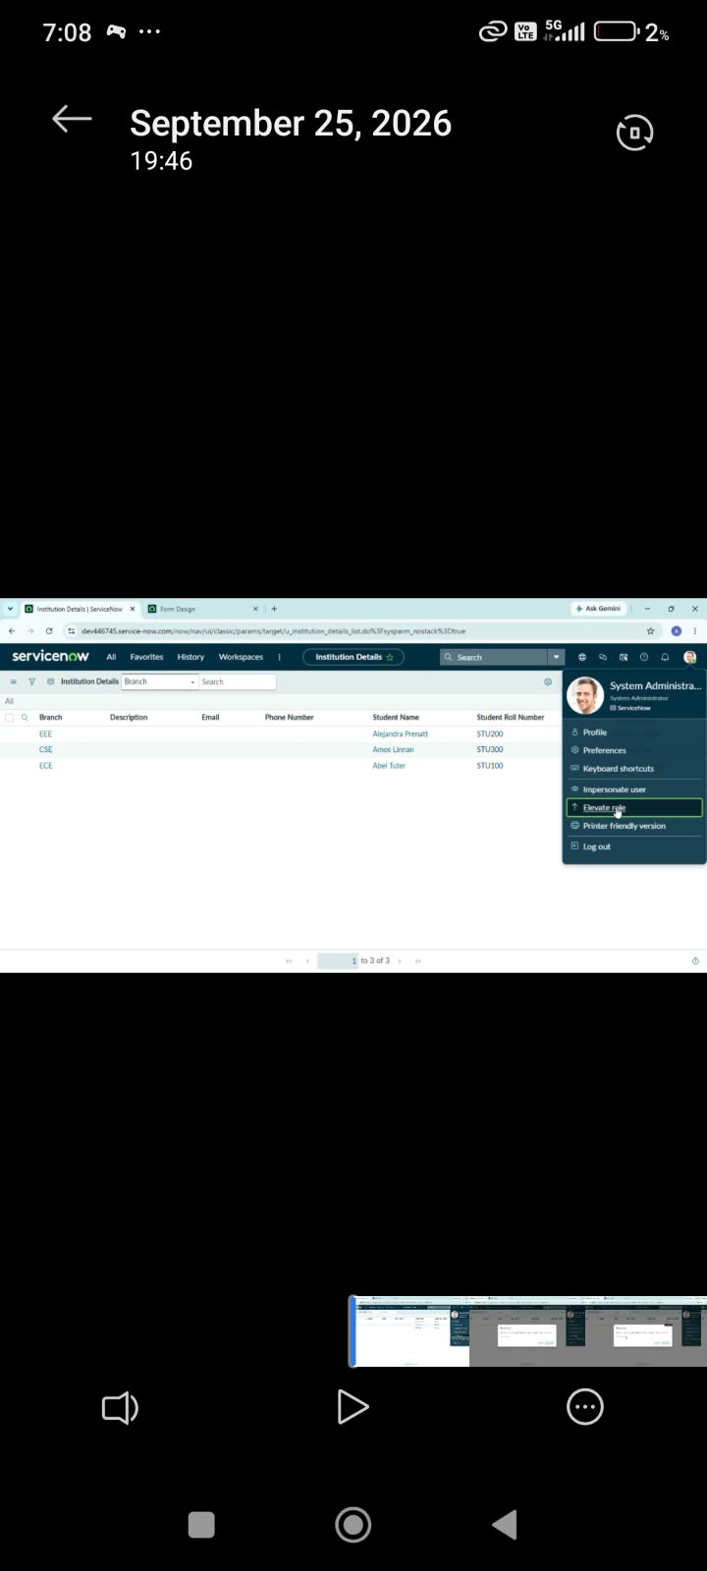  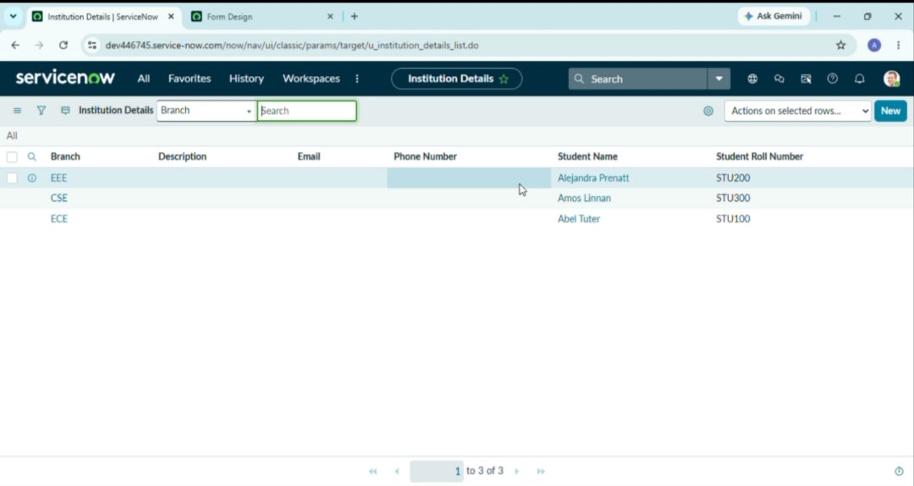
 | Rule Validation | Field Value Check –  Validate the configured field value before granting access.  Script Execution –  Confirm the ACL script executes the required condition correctly.  Negative Testing –  Verify restricted records are not exposed when the condition fails. | 